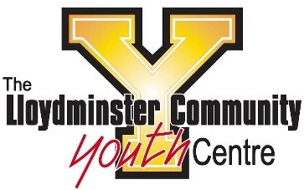

Assumption of the Risk and Waiver of Liability
Relating to the Coronavirus/Covid19

The novel coronavirus, COVID-19, has been declared a worldwide pandemic by the World Health Organization. COVID-19 is contagious and is believed to spread mainly from person-to-person contact. As a result, all levels of government and health agencies recommend physical distancing and limitations on group size.
The Lloydminster Community Youth Centre has put in procedures to adhere to the government’s guidelines (as listed on the Government of Saskatchewan website (www.saskatchewan.ca/COVID19) to reduce the spread of COVID-; however, LCYC cannot guarantee that your youth will not become infected with COVID-19. All program guidelines are subject to change with no notice upon government recommendations and requirements. Attending LCYC could increase the risk of contracting COVID-19.
By signing this agreement, I _______________ acknowledge the contagious nature of COVID-19 and voluntarily assume the risk that my youth may be exposed to, or infected by COVID-19 by attending programs at LCYC and that exposure or infection may result in illness, health complications or death. I understand that the risk of becoming exposed to, or infected by COVID-19 may result from the actions, or omission of myself and others including staff, volunteers, and other program participants and families.
I voluntarily agree to assume all risks and accept sole responsibility for any issues or complications my youth or myself experience in connections with participation in LCYC programming. On my behalf, and on behalf of my youth, I hereby release and hold harmless LCYC, its employees, the program facility and all representative from all liabilities, claims, actions, damages, arising out of or relating thereto. I understand that this release includes any claims based on the actions or omissions of LCYC, staff, and representatives, whether a COVID-19 infection occurs before, during, or after participation in any LCYC program.

____________________________ ________________________
Signature of Parent or Guardian Date

____________________________
Print Name of Parent or Guardian

____________________________
Name(s) of Youth Participant(s)

